**PROVIDE TRADITIONAL GAMES PROJECT**

**FACULTY OF LANGUAGE CENTRE**

**SUBJECT (UHE3072)**

**TECHNOLOGY FOR HUMAN CAPITAL**

1. **PURPOSE**

This paper aims to present a Traditional Game Program implemented by our group of 'Pineapple Frame' and the expenses incurred for the success of the program

Traditional Games Programme had been implemented with the aim to achieve the set objectives, namely: -

* Expose students of University Malaysia Pahang (UMP) with closer background Traditional Games in Malaysia.
* To build and strengthen the relationship between students of University Malaysia Pahang (UMP).
* Participate in and learn to play traditional games are a tradition since time immemorial.
* Gain experience, understand and appreciate the concept of unity in line with the 1Malaysia concept through such programmes.

1. **PARTICIPATION**

Programme participation is open to 20 students of Universiti Malaysia Pahang (UMP). The response to the programme was satisfactory, with the participation of 26 students in line with the targets set by us. Students with multiple majors who participate in this programme are FSKKP, FKASA, FIST, FTECH and FSSKA. No fee is charged to every student enrolled in this programme.

1. **FINANCIAL PROVISIONS**

For the success of this programme, the allocation of RM50.00 been spent. Provision has been spent is used to cover the cost of students during the souvenir session program. A summary of the provisions of the programme is spent in the table below.

|  |  |  |  |  |  |
| --- | --- | --- | --- | --- | --- |
| **NO** | **ITEM** | **PRICE PER UNIT (RM)** | **UNIT**  **AMOUNT** | **TOTAL**  **(RM)** | **NOTE** |
| **1** | souvenir | 1.50 | 20 person | 20 |  |
| **TOTAL** | | | | **RM** | **50.00** |

1. **PROJECT TENTATIVE**

|  |  |
| --- | --- |
| 9:00 – 9.30 am | Student Registration |
| 09:30 – 10:35 am | Talk 1: Introduction and teach how to play traditional games   1. Congkak 2. Batu Seremban |
| 10.35 – 12.40 pm | Module 1 : Start playing traditional games |
| 12:40 – 2.00 pm | Lunch, Prayer and Rest |
| 2:00 – 2.45 pm | Talk 2: Introduction and teach how to play traditional games   1. Dam Haji 2. Guli Tanah |
| 2.45 - 4.30 pm | Module 2 : Start playing traditional games |
| 4.30 –4.45 pm | Souvenir session |
| 4.45 – 4.55 pm | Last speech for the students from team members of project  Photograph session |
| 5.00 pm | All Students Dismiss |

1. **ACTIVITY REPORT**

**REPORT HEAD OF PROGRAMME**  
  
**Head of Programme:**

* Nur Aqilah binti Mohd Sabandi

**Types of activities that will be conduct:**

Implementation of Traditional Games

**Early planning:**

Discussions with other Implementation Committee to propose Traditional Games programme at Universiti Malaysia Pahang.

**The process of preparing the equipment, before, during and after the programme.**

**A. Before the programme**

* Provide all directions to all Program Implementation Committee.
* Ensure the Implementation Committee to carry out tasks as possible.

**B. During the program**

* Provide briefings on Traditional Games participants.
* Deliver souvenirs to the participants.

**C. After the programme**

* The event ended successfully with the help of the Programme’s Implementation Committee.

**REPORT OF IMPLEMENTATION PROGRAMME COMMITTEE**

**Implementation of Programme Committee:**

* Wan Nur Hafeza Haslinda Binti Wan Hassan
* Yogendran A/L Velaeidom
* Kalaiyarasan A/L Ramasamy

**Types of activity that will be conduct:**

Implementation of Traditional Games

**Early Planning:**

* Discussion with the Head of Programme Implementation Committee and others to propose that the Program Traditional Games at Universiti Malaysia Pahang.
* A number of activities have been proposed by the Implementation Committee in the discussion of play batu seremban, congkak, guli tanah and dam haji.

The process of preparing the equipment before, during and after the programme.  
  
**A. Before the programme**

* Discussion of Programme Implementation Committee to provide a list of equipment needed to the Traditional Games Programme.
* Discussion of Programme Implementation Committee with the Head of Programme to determine the location of which will be elected for implementing the Traditional Games.
* Discussion with the Head of Programmes for approval of the proposed activities for the

Programme Day with the "Traditional Games".

* Providing souvenirs based on the budgets allocated for the programme participants.

**B. During the programme**

* Giving souvenirs as a token of appreciation to the participants after the program runs.
* One of the Implementation Committee which was appointed to be the host of the progra.
* Take a list of participants who attended this program registration session.

**C. After the programme**

* The event ended successfully.

1. **ACTIVITY OF PROGRAMME**

Traditional game programme was held on December 14, 2013 (Saturday). The participants are requested to assemble at the Residential College Student Longue 3 UMP before 9.00 am which was scheduled at 9:05 am and students are required to enrol in Committee members on duty to facilitate the number of participants can be listed. 9:30 am and a brief introduction to Traditional Games and How to Play Traditional been served by the programme. The time allocated for briefing participants are for 1 hour.

Exactly at 10.35 am, the first module of the programme is beginning to play traditional games. After a brief overview is given of how to play the traditional game, students are given time to try and to experience playing traditional games with friends. The first module, various antics and scenarios presented participants. Some of them are very excited to play this kind of game. This shows that we have achieved some goals of these programmes are implemented. We hope to be bonded fraternity of brotherhood among the students of various majors. Then, 2 hours and 15 minutes of the session went on the first module to be implemented effectively. The participants were given permission to return to their accommodation for personal needs (food, rest & pray). Given time is 1 hour 20 minutes.

In the afternoon, precisely at 2:00 pm, the second module is a continuation of a program to play the traditional game. Students who have not had the opportunity to play in the first module in the morning, was now given time to try and to experience playing traditional games with friends. Subsequently, 2 Hours 15 Minutes went on and ended the session second module. After that, the program continued with a session present gifts to the participants of the program by the end of the program and a speech by the Programme Implementation Committee work tirelessly to ensure that the programmes can be implemented. Before ending the program, organized a photo session with the participants and everyone involved in the programme.

The cooperation and support of all parties, ultimately Day’s Programme with "Traditional Games" can be implemented successfully. This programme was exposed and opened the eyes of the participants on Traditional Games of the cultural heritage that should be preserved to posterity not expire. In addition, the opportunity to see and taste of traditional games has also increased knowledge and opens the eyes of the students. The hope with the availability of such programmes in the years to come, it will increase their knowledge about the 'wealth' owned Malaysian society.

1. **LEARNING OUTCOMES**

What we have learned from handling these traditional games programme are:

**Good community**

We can know each other and met new friends by share some knowledge about traditional games and playing the traditional games.

**Improve leader skill**

A leader should work to be the motivator, an initiator. We must be a key element in the planning and implementing of new ideas and programme. By handling the programme, we also can increase the confident level. It is because while handling the programme, we will learn that how make people can hear and follow leader’s instructions.

**Team Work**

Team work is the most important when doing something work especially to handle the programme. If team work have their strengthen, the programme will run smoothly as planned because the group members is always give the commitment in task. Team working also will produce desirable result, share ideas with others, able to accept members weakness so that team members will helps each other.

**Handle Program**

Manage program to be one of the learning process. When handle the programme, also learn how to be punctual on time, hardworking to finish the task , learn how make the program run smoothly and successful.

**Decision making skills**

Decision making skills of the team work can be strengthened, through proper planning. For instance, if several alternatives could be taken to solve a problem, a decision must be made as to which one will be carried out. Ask for thoughts and comments from the team members, share and accept the ideas.

**7.0 PICTURES ATTACHMENT**

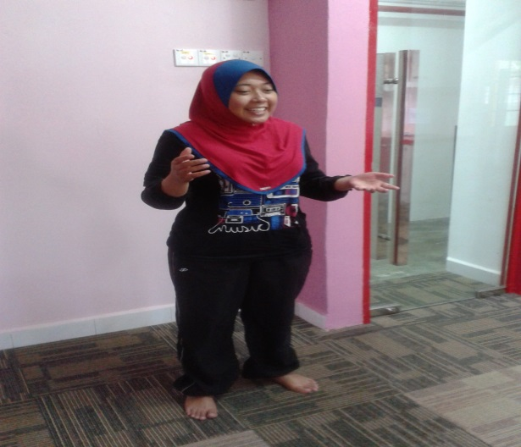 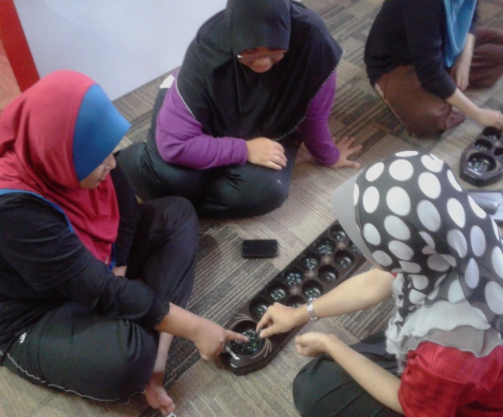

**Picture 1**: Briefing Traditional Games Rules **Picture 2**: Teach How to Play “Congkak”

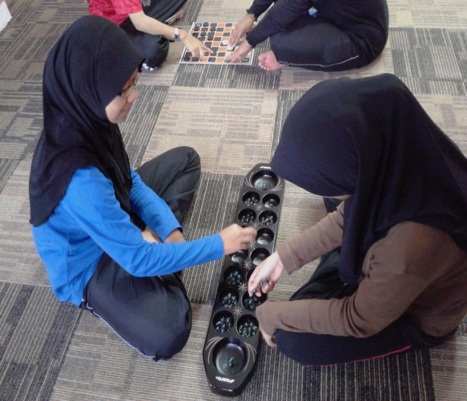 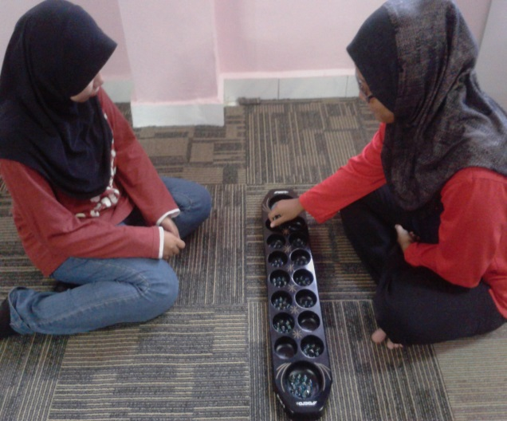

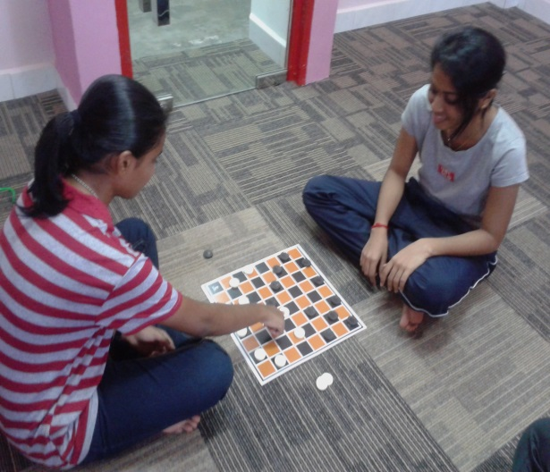 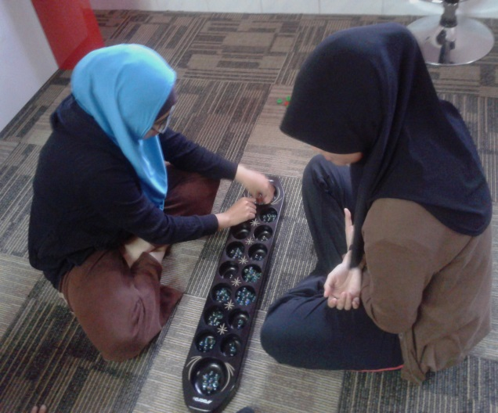

**Picture 3,4,5,6** : Start playing the “Congkak” Game.

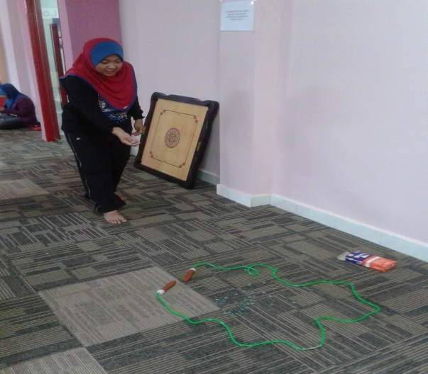 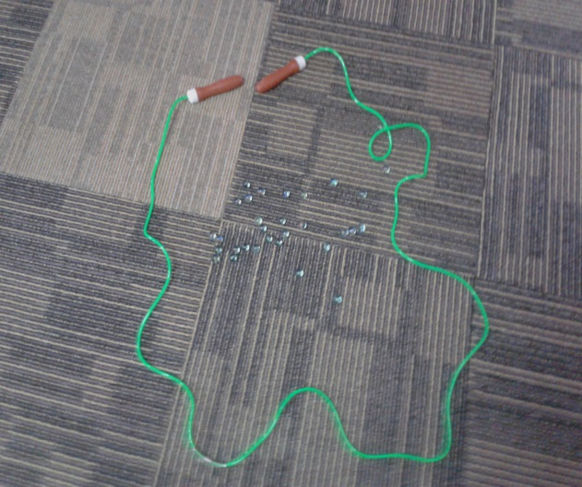

**Picture 7**: Teach How to play “Guli Tanah” **Picture 8**: Start Playing

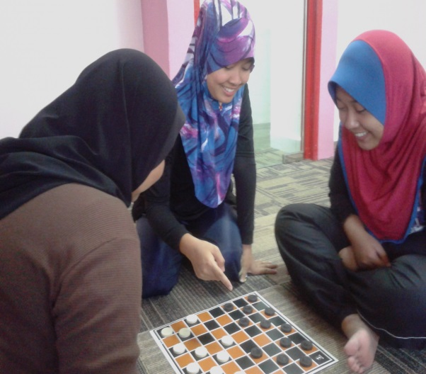 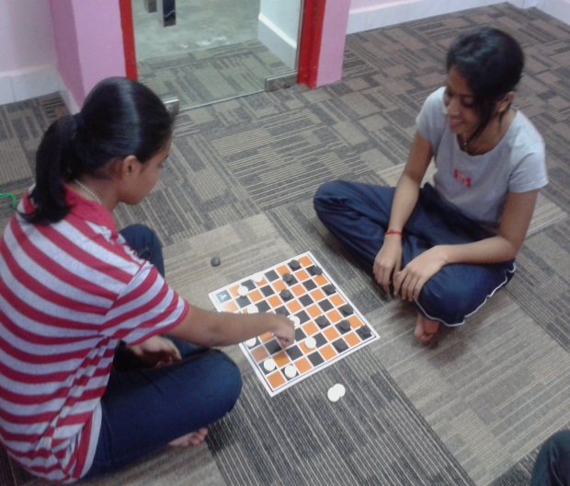

**Picture 9**: Teach How to play “Dam Haji” **Picture 10**: Start Playing

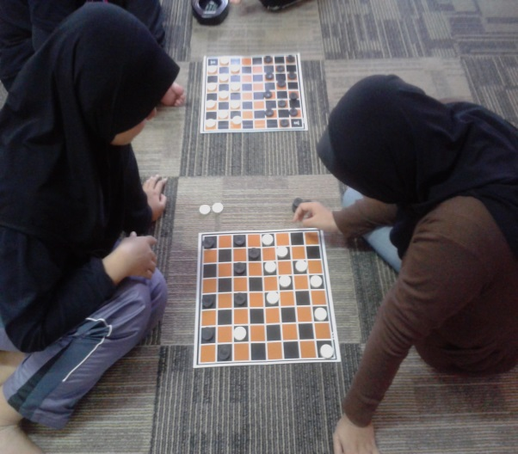 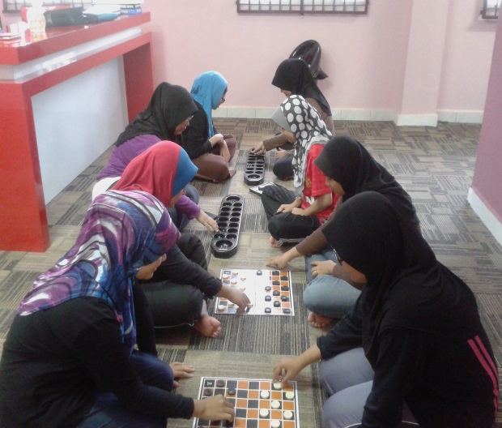

**Picture 11 & 12:** Students enjoy playing the Traditional games.

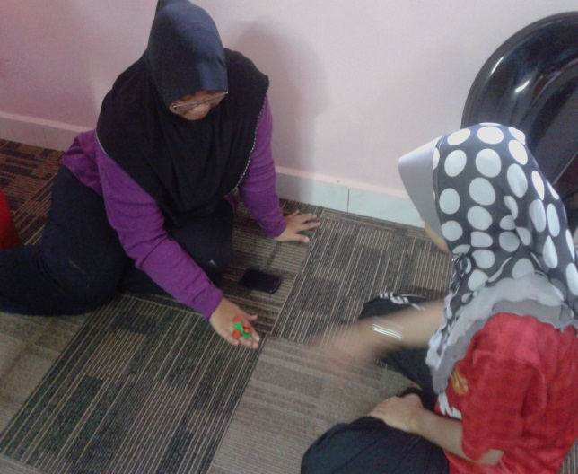 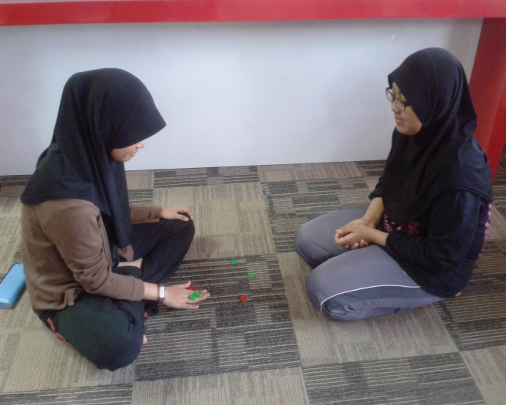

**Picture 13**: Teach how to play “Batu Seremban” **Picture 14** : Start Playing

**SOUVENIR SESSION**

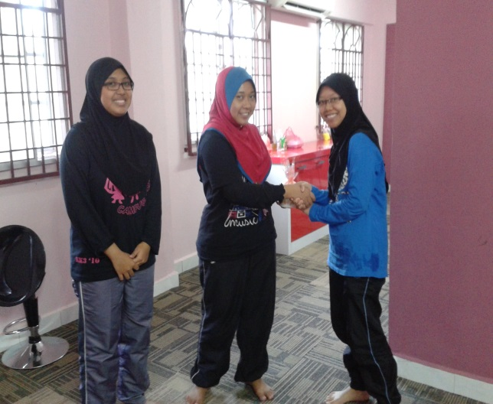 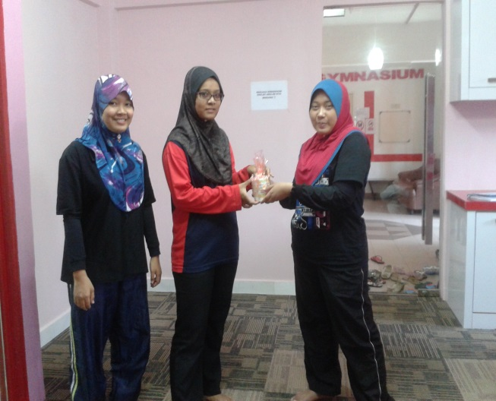

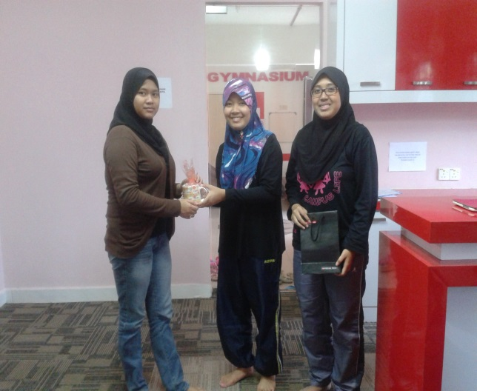 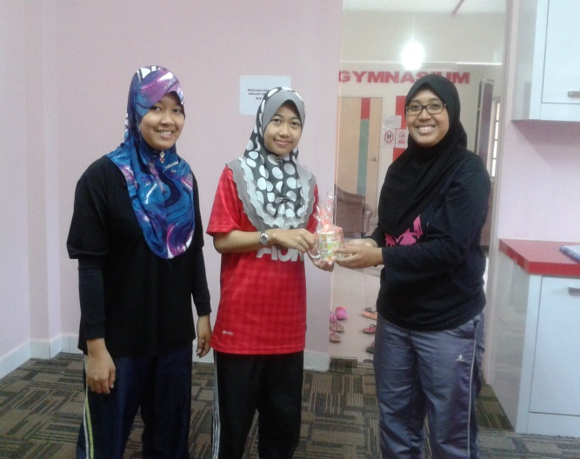

**Picture 15,16,17,18** : Give Souvenir to the students.

**PRIZES FOR THE WINNER**

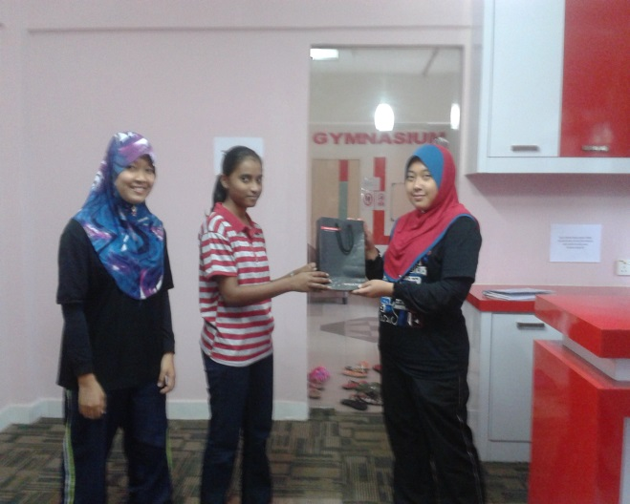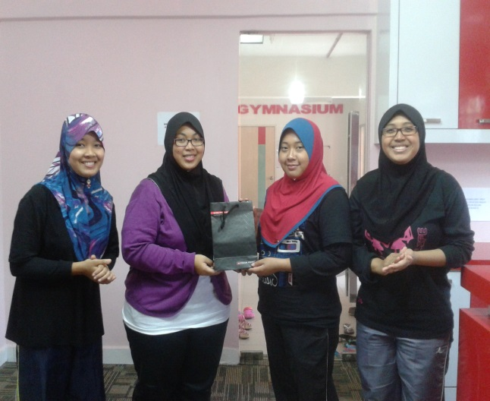

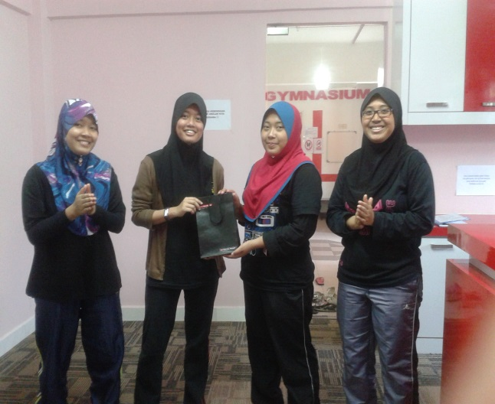 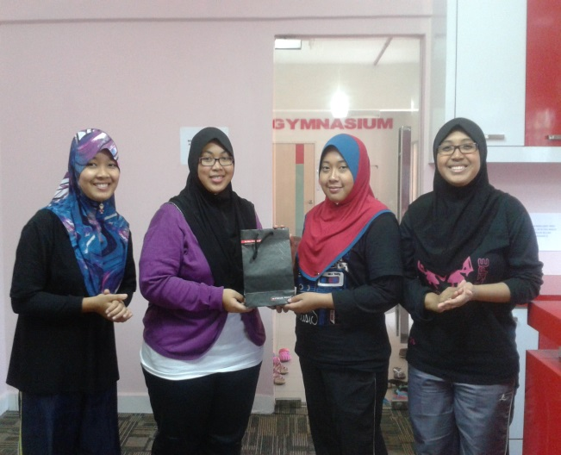

**Picture 19,20,21,22** : Traditional Games’winner

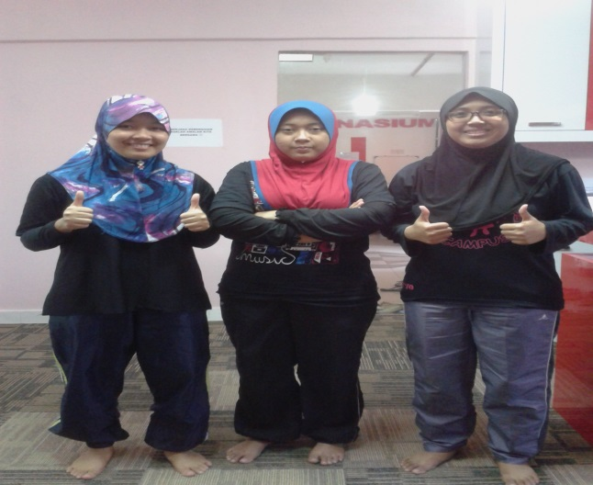 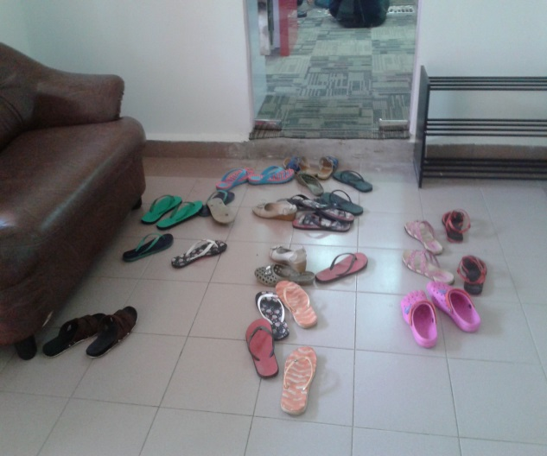

**Picture 23**: Photograph session **Picture 24**: Student dismiss at 5pm

1. **CLOSING**

**APPRECIATION**

We wish to express our sincere appreciation and gratitude to Assoc. Dr. Muhammad Bin Abdul Wahab Nubli in a trust and provide guidance and advice to our first project that we handle. Thank you to all the students of Universiti Malaysia Pahang (UMP) is very helpful and cooperative in ensuring that the activities run smoothly.

Finally, we also expect these program Traditional games can be beneficial to us all and we must use the experience and knowledge obtained is preferably to be used as a reference guide and supply in the future.

Thank you.

Report is prepared by:  
  
**(NUR SYUHAIDAH BINTI ISMAIL)**  
Secretary   
Traditional Games Program

Technology for Human Capital (UHE3072)

**APPENDIX A**

STUDENT LIST OF ATTENDANCE

PLAYING TRADITIONAL GAMES PROGRAMME

14 DECEMBER 2013

RESIDENTIAL KK3, UNIVERSITI MALAYSIA PAHANG

|  |  |  |  |
| --- | --- | --- | --- |
| NO. | STUDENT NAME | ID MUMBER | SIGNATURE |
| 1 |  |  |  |
| 2 |  |  |  |
| 3 |  |  |  |
| 4 |  |  |  |
| 5 |  |  |  |
| 6 |  |  |  |
| 7 |  |  |  |
| 8 |  |  |  |
| 9 |  |  |  |
| 10 |  |  |  |
| 11 |  |  |  |
| 12 |  |  |  |
| 13 |  |  |  |
| 14 |  |  |  |
| 15 |  |  |  |
| 16 |  |  |  |
| 17 |  |  |  |
| 18 |  |  |  |
| 19 |  |  |  |
| 20 |  |  |  |
| 21 |  |  |  |

**APPENDIX B**

**SATISFICATION TRADITIONAL GAMES PROGRAMME**

**Please fill this satisfaction survey form :**

1. Do you like this traditional games programme?

* Yes
* No

2. Please select the traditional games that you play in this programme :

* Congkak
* Dam Haji
* Batu Seremban
* Guli Tanah

3. How would you rate your knowledge about traditional games after join this programme?

* Very advance
* Advance
* Average
* Basic
* Nothing

4. Complete the following statement by choosing the most closely matches your opinion:

This traditional games programme is ;

* Boring
* Easy
* Difficult
* Useless
* Enjoyable

­*Thank you for fill this form ☺

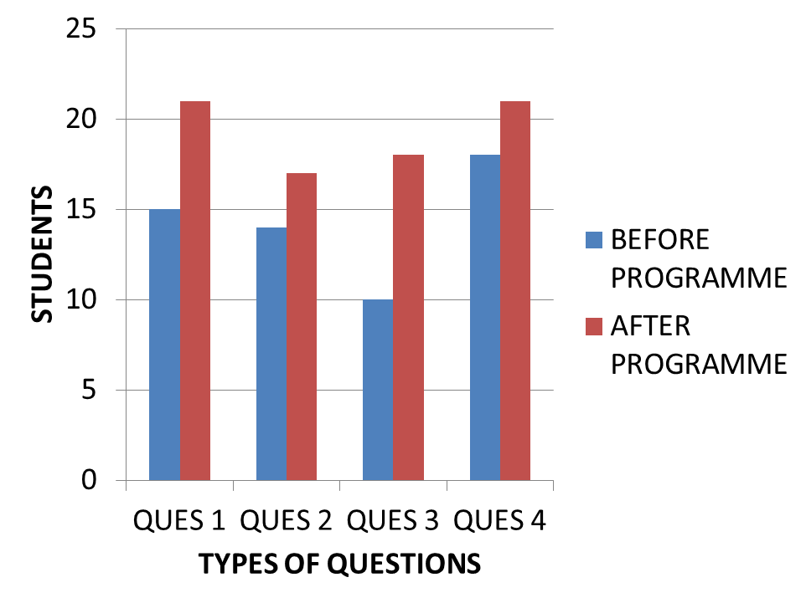

Berdasarkan Graph di atas, kajian menunjukkan kepuasan pelajar tentang Program Permainan Tradisional Seramai 87% berbanding sebelum program ini dijalankan dan menyatakan ianya sangat menarik dan mudah dipelajari. Manakala 13% berpendapat tidak mendatangkan apa-apa manfaat dan membosankan. Hanya 87% sahaja yang sangat teruja untuk bermain. Keseluruhan pelajar dalam kajian adalah seramai 20 orang.

**APPENDIX C**

**FLYERS FOR INVITATION TO TRADITIONAL GAMES PROGRAMME**

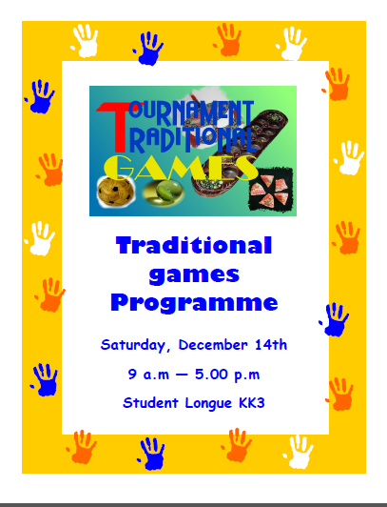

**APPENDIX D**

**BROCHURE MODULE TRADITIONAL GAMES**

**PERMAINAN TRADISIONAL**

Permainan tradisional berupaya membentuk sebahagian daripada kehidupan yang dilalui oleh nenek moyang kita. Perkara utama yang menjamin kesinambungan permainan tradisional pada masa lalu ialah keseragaman cara hidup nenek moyang kita. Permainan tradisional juga dikenali sebagai permainan rakyat.

**JENIS PERMAINAN TRADISIONAL.**

1. **BATU SEREMBAN**

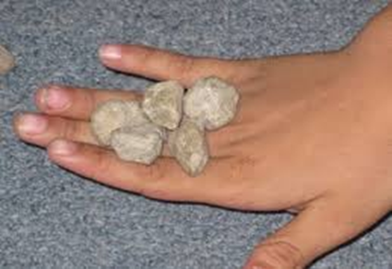 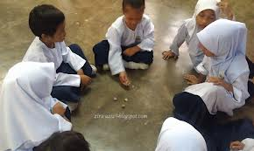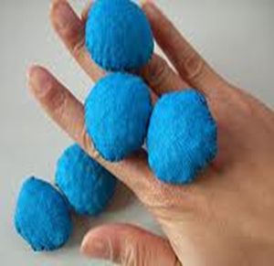

* Batu Seremban juga dikenali sebagai permainan Selambut atau Serembat.
* Permainan ini dimainkan oleh kanak-kanak perempuan sama ada secara individu atau berpasangan.
* Ianya dimainkan secara berkumpulan seramai dua hingga empat orang atau lebih.
* Biasanya ia menggunakan guli kaca, biji getah, ketul batu yang kecil atau ketulan-ketulan objek lai berbentuk bulat.
* Bilangan yang biasa digunakan sebanyak lima biji ataupun tujuh biji.
* Objek-objek ini dikenali sebagai buah.

**Cara Bermain**

1. Pemain utama memulakan permainan dengan cara menaburkan buah seremban.
2. Jika ada buah yang bersentuhan, maka status pemain ini dianggap mati.
3. Setiap peringkat buah adalah berbeza mengikut urutan aturan yang telah ditetapkan.
4. Bermula sebagai buah satu hinggalah kepada peringkat lebih tinggi atau peringkat yang teratas dinamakan buah tujuh.
5. Kemudian melakukan imbangan buah bagi mendapatkan mata.
6. Pemain yang berjaya memperolehi mata paling tinggi dikira sebagai pemenang.
7. **DAM HAJI**

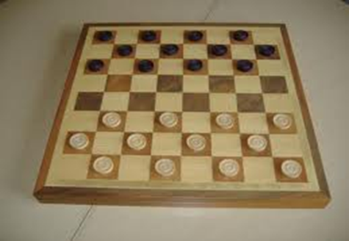 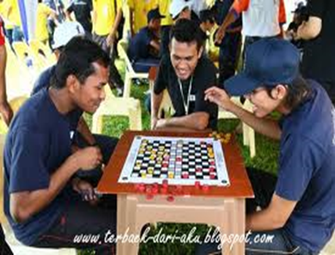

* Permainan strategi ini dimainkan secara individu.Selain kanak-kanak lelaki, lelaki dewasa, juga menggemari permainan ini.
* Permainan ini dimainkan di kwasan anjung rumah. Manakala lelaki dewasa lebih gemar bermain di kedai kopi sambil berbual kosong.
* Setiap pemain berusaha mengalahkan lawan masing-masing dengan cara memakan buah dan lawannya.
* Permainan ini mengambil masa yang agak lama kerana setiap pemain

**Cara Bermain**

1. Berfikir dan berupaya memerangkap pihak lawan bagi mengalahkannya.
2. Pemain yang berjaya memakan kesemua buah dam milik lawannya dianggap memenangi permainan ini.
3. Status seri juga boleh berlaku jika kedua-dua pemain gagal mengalahkan lawan masing-masing.
4. **GULI TANAH**

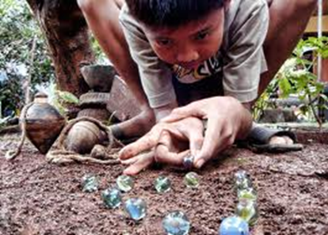 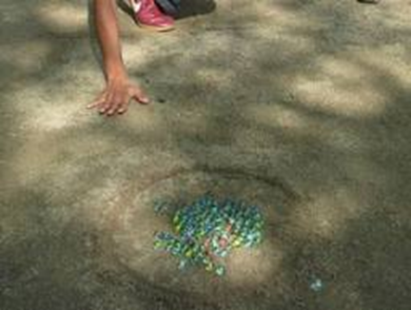

* Permainan ini sering dimainkan oleh kanak-kanak lelaki
* Setiap pemain perlu mempunyai beberapa guli taruhan dan satu guli induk.

**Cara Bermain**

1. Satu bulatan digoreskan di atas tanah .Kesemua guli taruhan di letakkan di dalam bulatan.
2. Permain pertama memulakan permainan dengan cara melontar guli induknya dan disasarkan kea rah guli taruhan yang berada didalam bulatan.
3. Guli taruhan yang keluar dari bulatan dikutip menjadi miliknya. Manakala guli induk tidak boleh disentuk atau diambil.
4. Sekiranya guli induknya tersangkut didalam bulatan, manakala status pemain ini dikira mati.
5. Pemain yang Berjaya menambah koleksi guli masing-masing dianggap sebagai pemenang.
6. **CONGKAK**

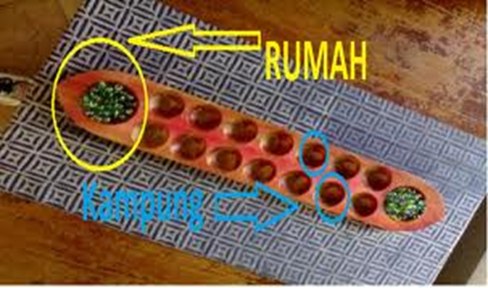 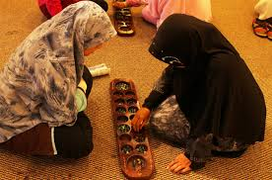

* Permainan congkak ialah sejenis permainan Melayu tradisional yang digemari oleh kaum wanita dan kanak-kanak.
* Permainan ini memerlukan dua orang pemain.
* Alatan yang digunakan dalam permainan ini adalah papan congkak dan buah congkak.
* Kadang-kadang sebagai ganti papan congkak, lubang-lubangnya dibuat di atas tanah.
* Sementara biji-biji congkak pula ialah guli-guli kaca, buah getah, biji saga, batu-batu kecil dan sebagainya.
* Setiap papan congkak hanya boleh dimainkan oleh dua orang sahaja.
* Papan congkak mengandungi 14 lubang yang dipanggil "kampung". Terdapat dua lubang besar di setiap hujung papan congkak. Lubang ini dipanggil "rumah".

**Cara Bermain**

1. Permainan ini dimulakan serentak dengan memasukkan sebiji "buah" ke dalam setiap "kampung" sendiri dan seterusnya masukkan ke dalam "rumah". Seterusnya "buah" hendaklah dimasukkan ke dalam "kampung" lawannya. Jika ia singgah di kampung lawan yang tidak ada buah ia dikira mati.
2. Jika buah terakhir singgah di kampung lawan yang mempunyai buah, maka ia boleh meneruskan permainan.
3. Jika ia mati di kampung sendiri, bertentangan dengan kampung lawan yang mempunyai buah, ia berhak mengambil buah lawannya itu.
4. Sekiranya ia mati di kampung sendiri setelah melalui kampung lawan dan didapati di kampung lawan tidak ada buah, maka ia mati dalam kerugian.
5. Di akhir permainan buah hanya tinggal beberapa biji sahaja dalam kampung masing-masing. Mereka dikehendaki berjalan tapak secara serentak menuju ke arah rumah masing-masing. Sekiranya salah seorang kehabisan buah dalam kampung ianya dikira kalah